Data Transformation:
1.Click the Power Bi and click the Get data ,Imported the “Order Details.csv” and “Sales target.csv” into Power Query Editor.
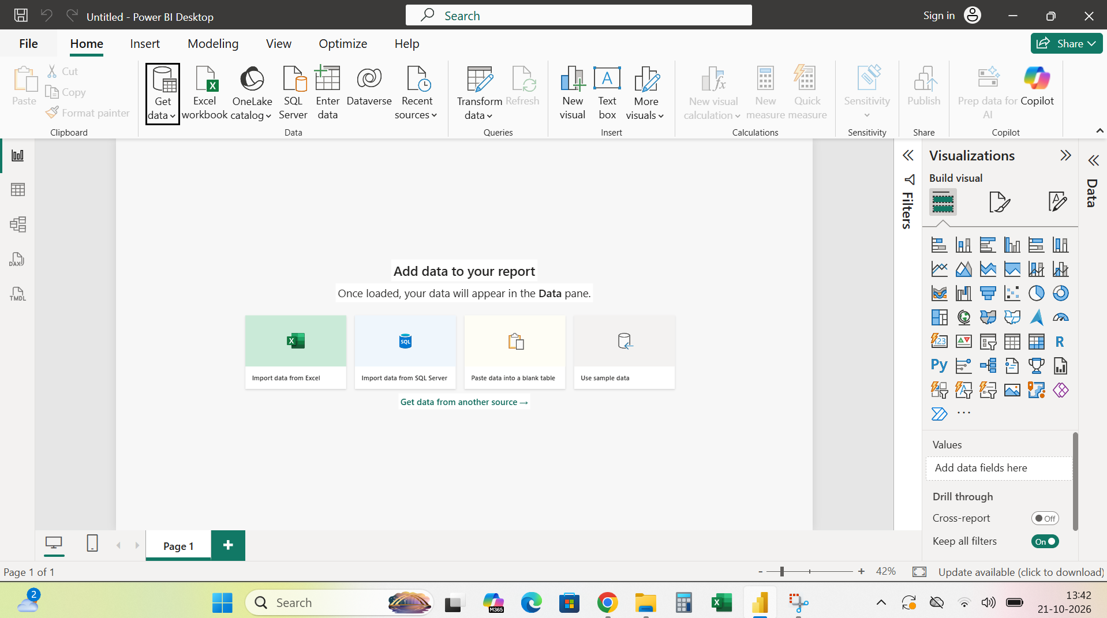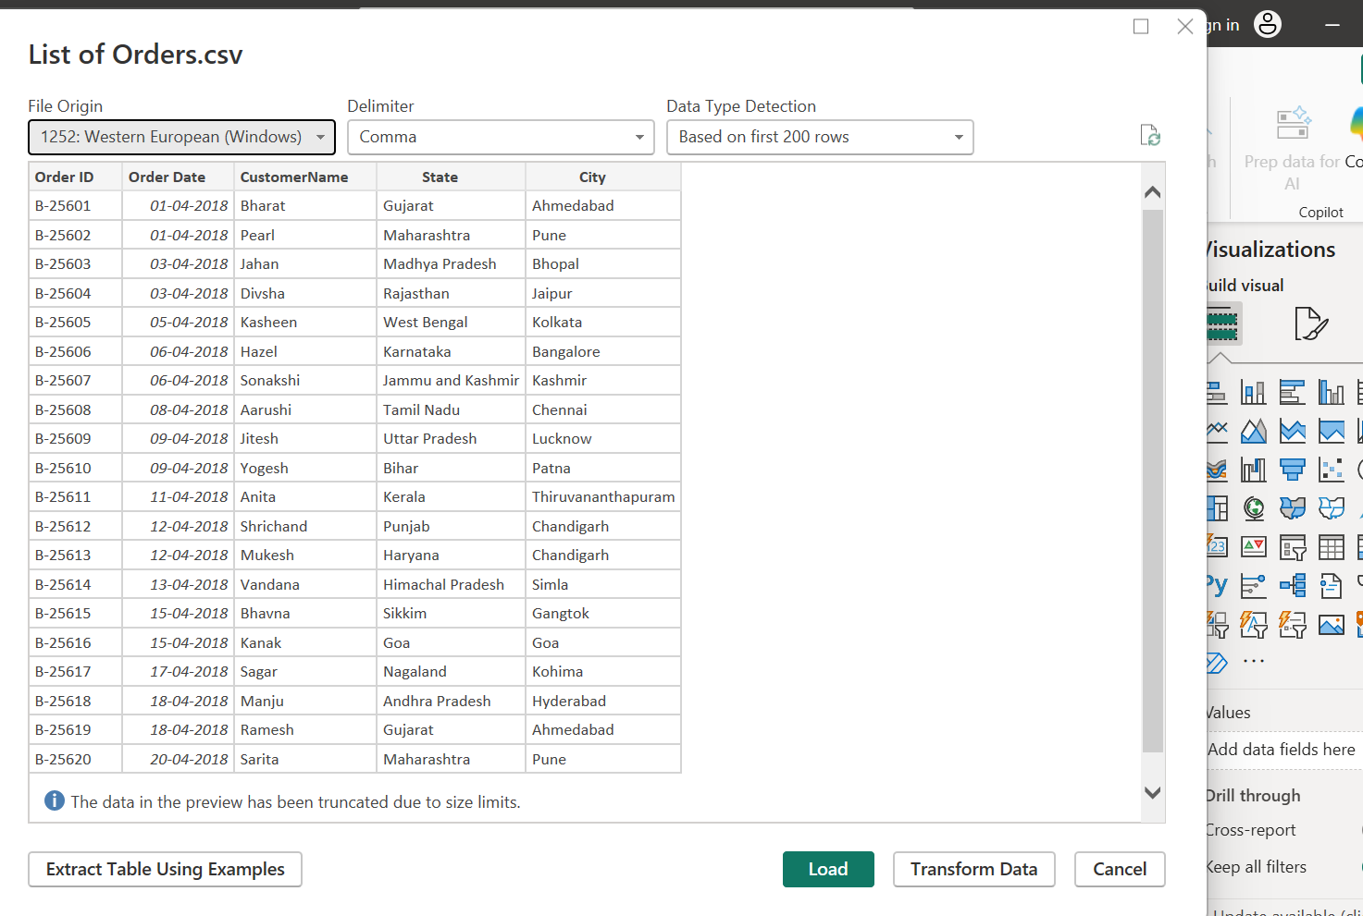
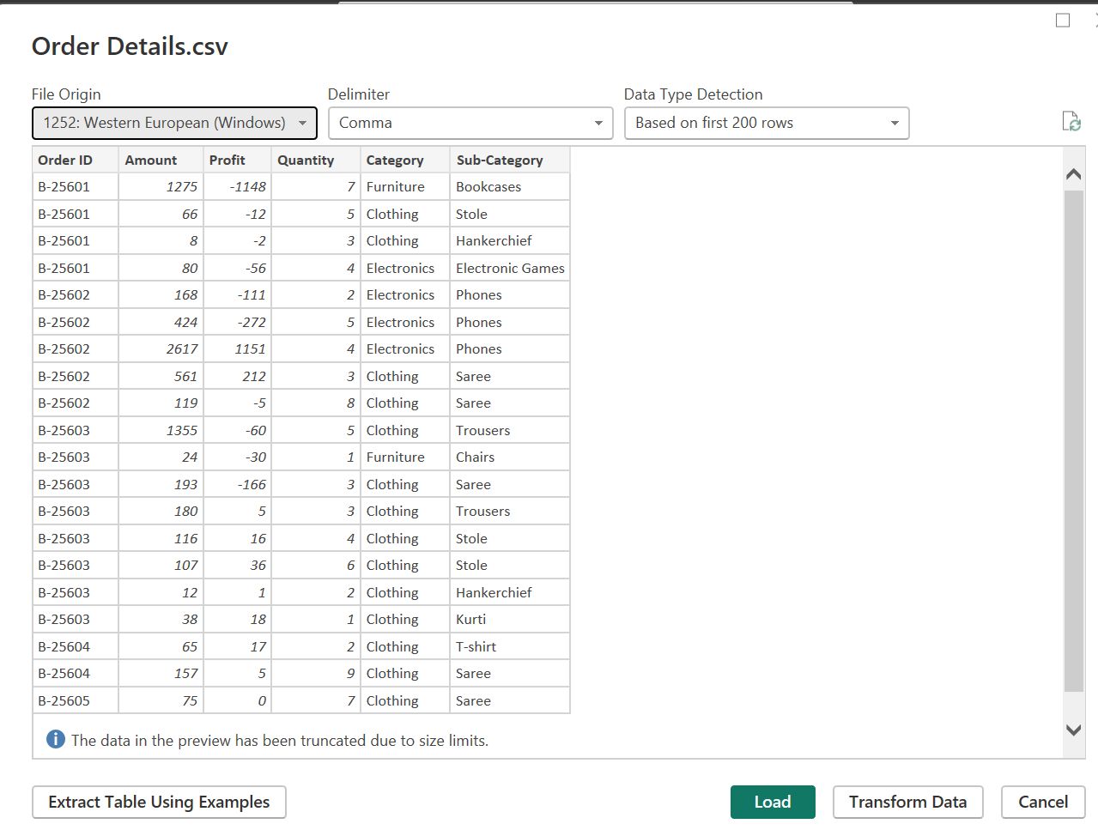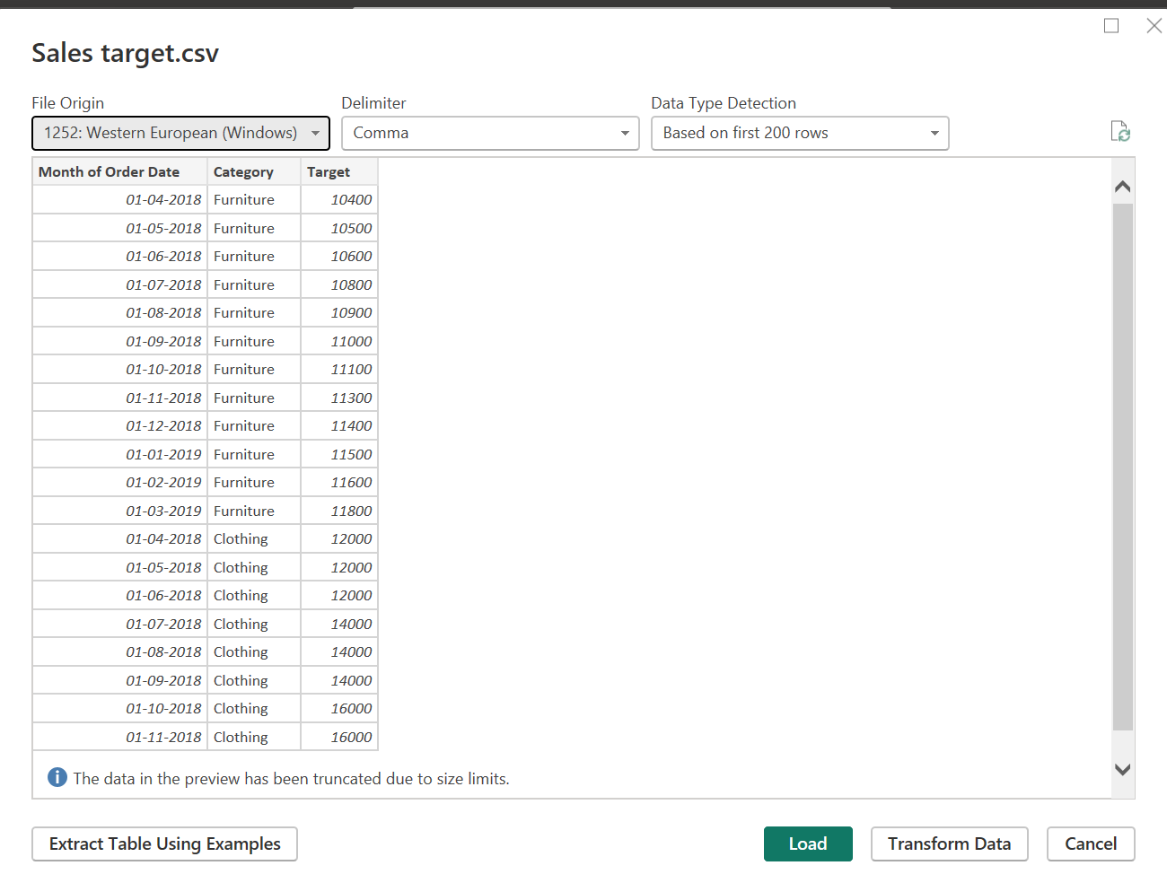

2.Transform the data
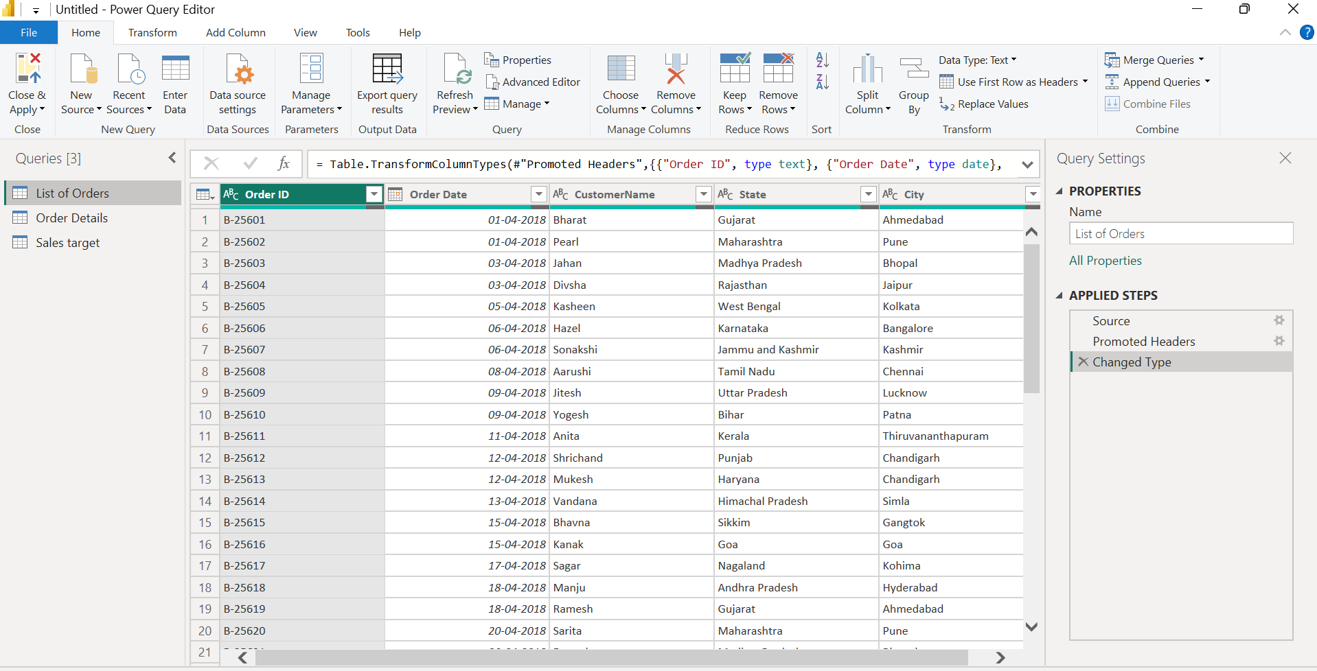
3.Start to the cleaning data Removed the bottom rows

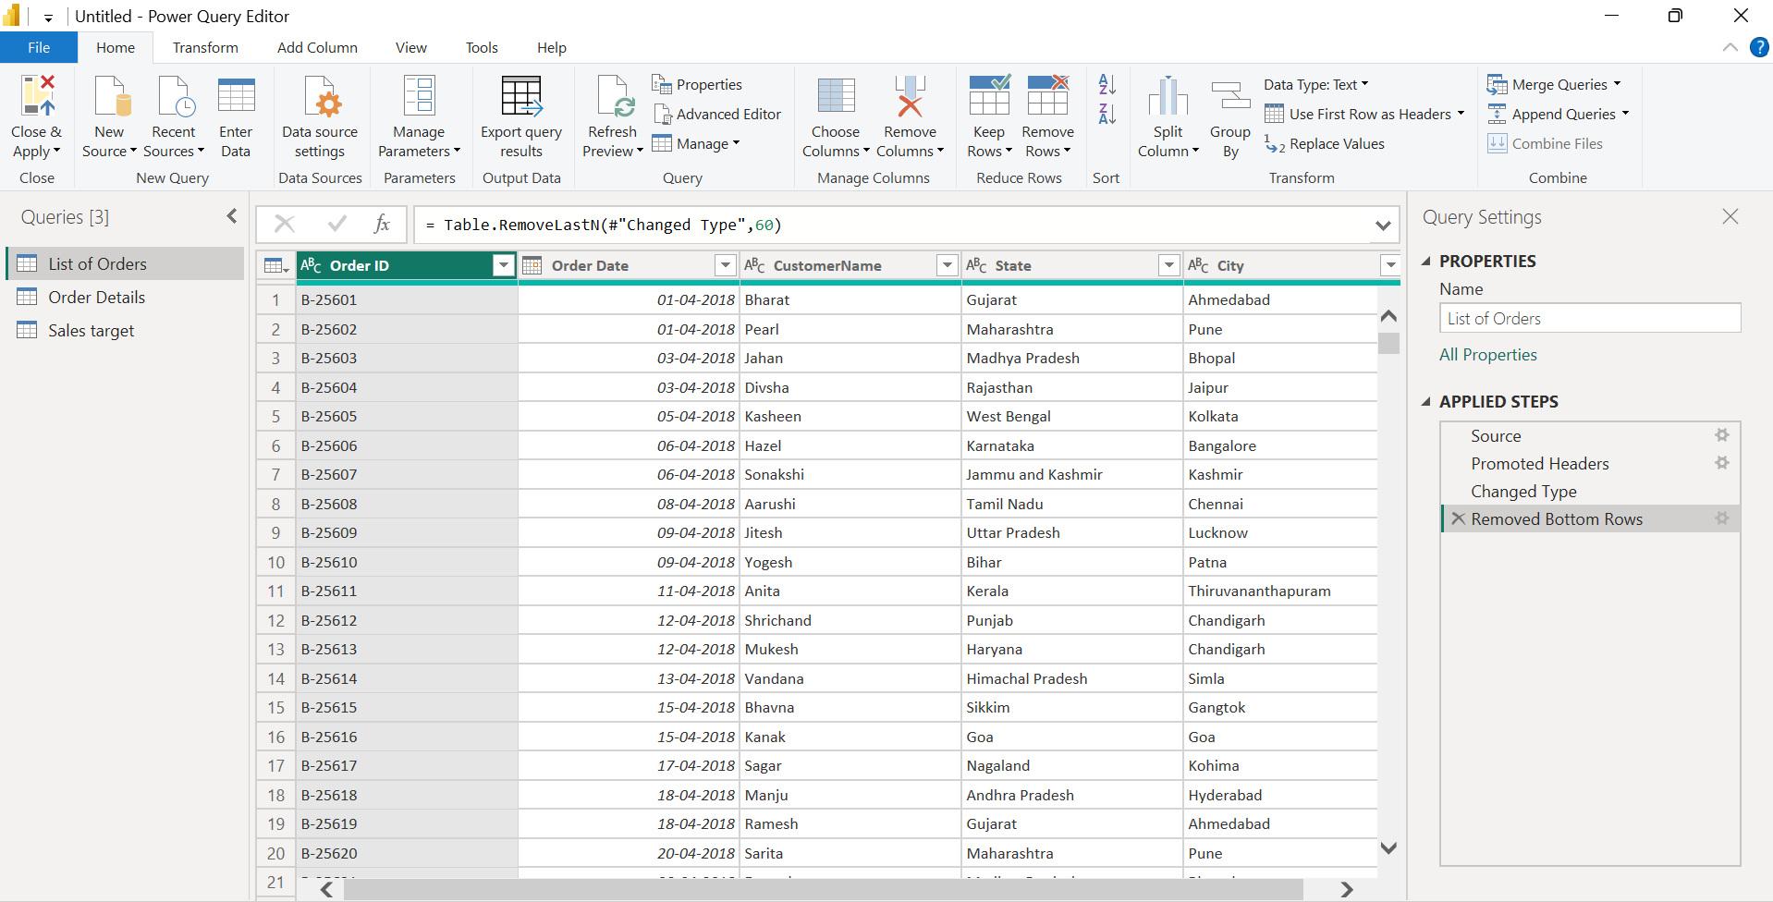
4.Changed the data type to date
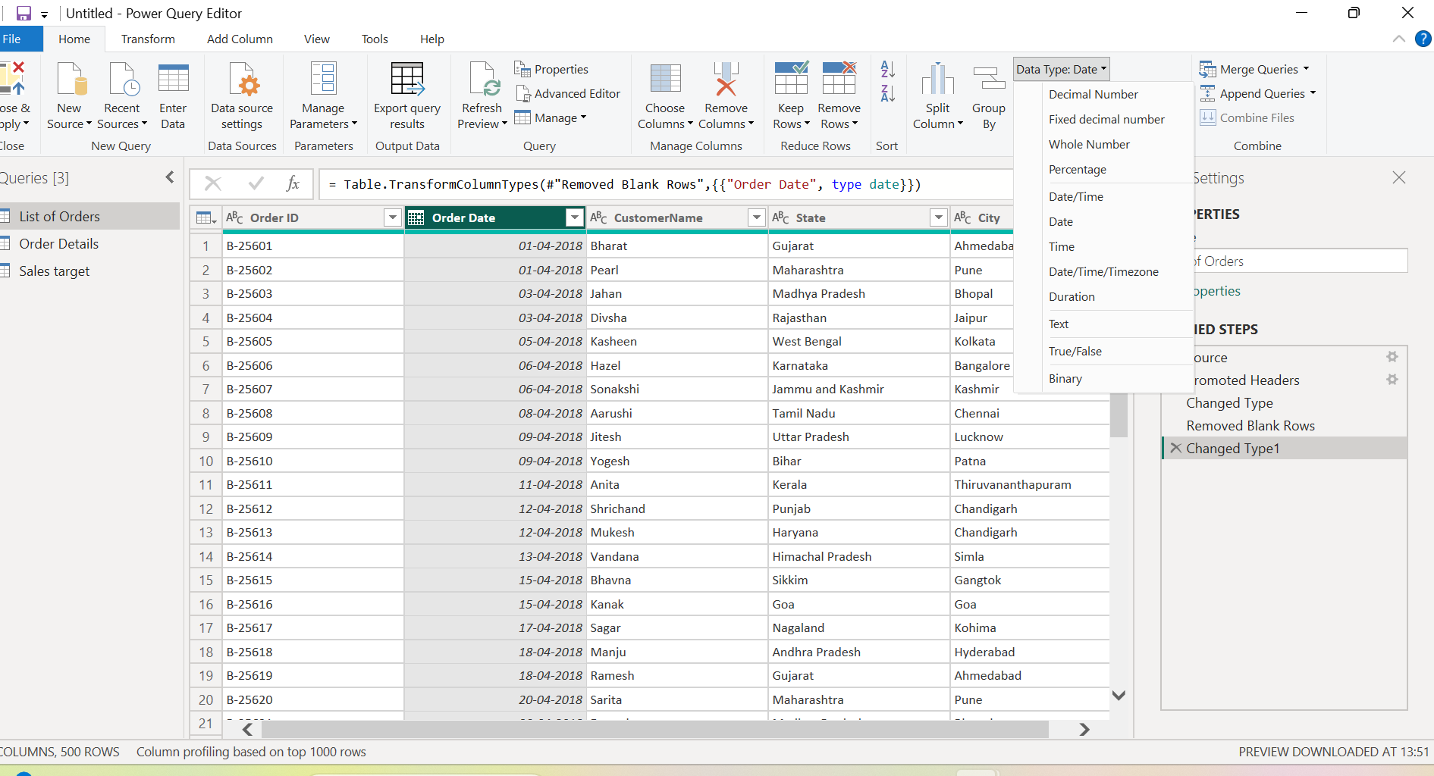
5.Changed the "CustomerName" column into proper case
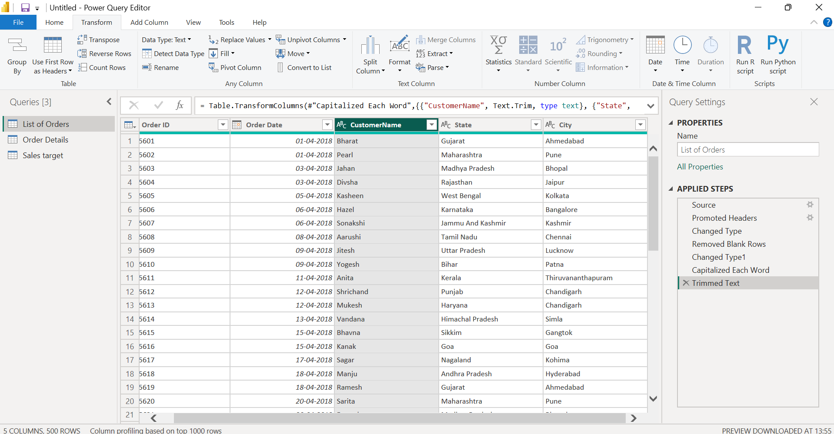
6.Merged the "State" and "City" columns to create a new column named "Location"
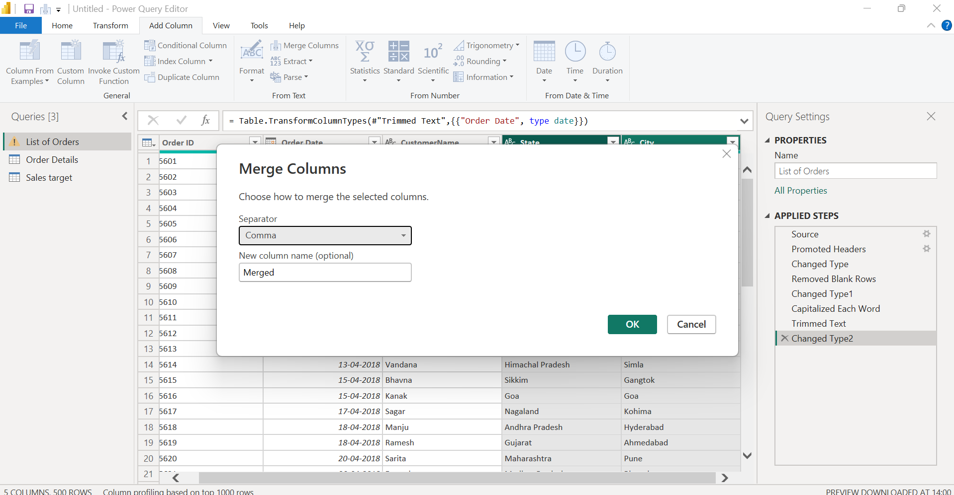
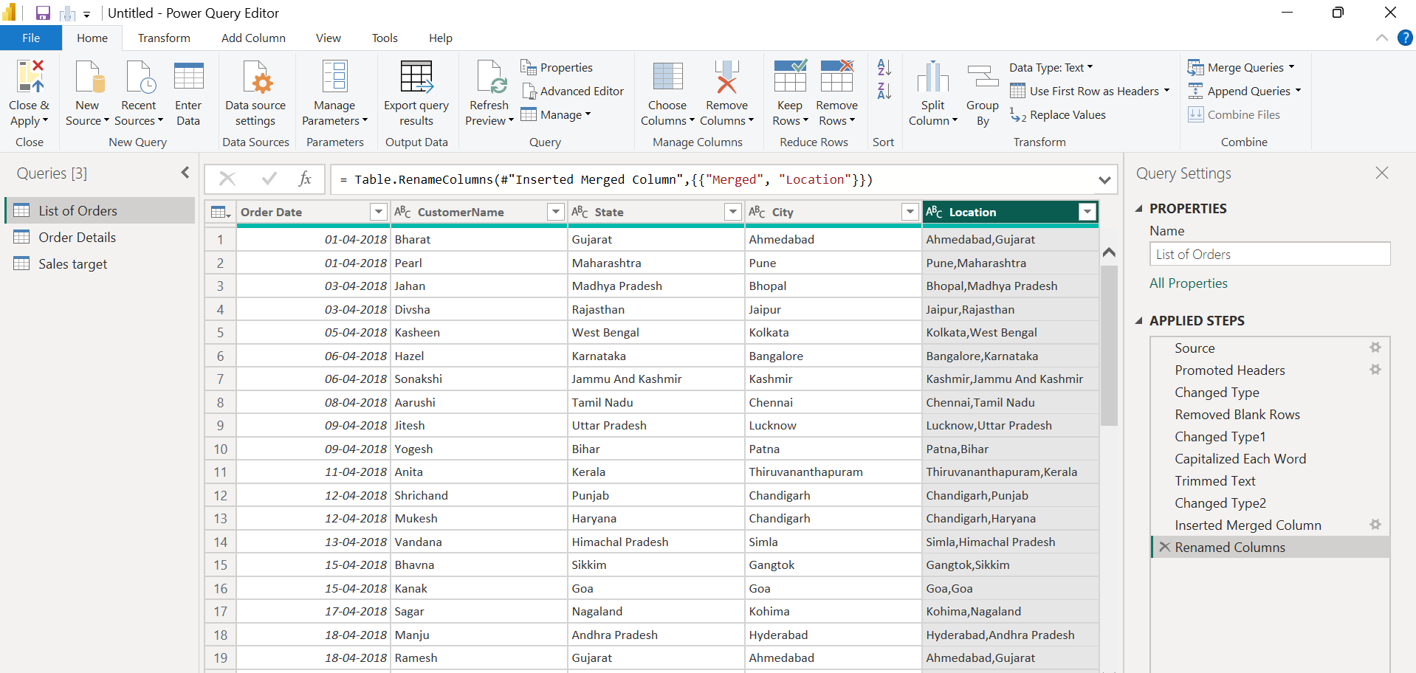
7.Changed the data type of “Amount” and “Target” columns to ‘Fixed Decimal Number’.
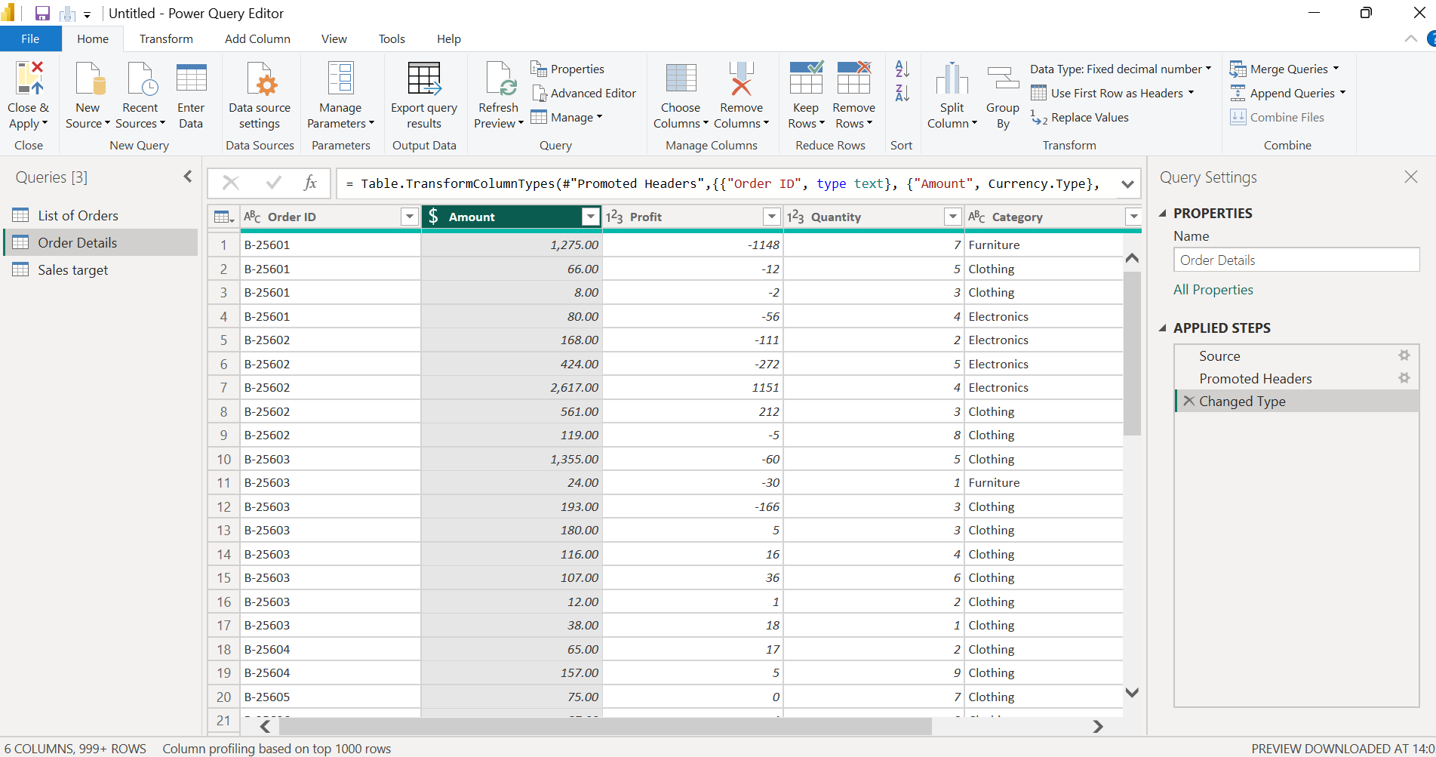
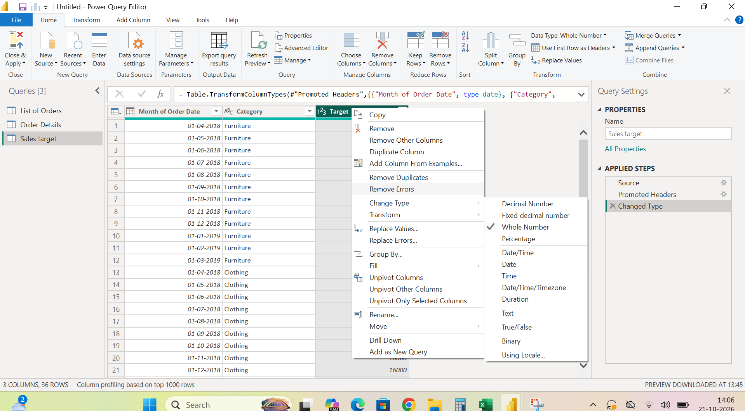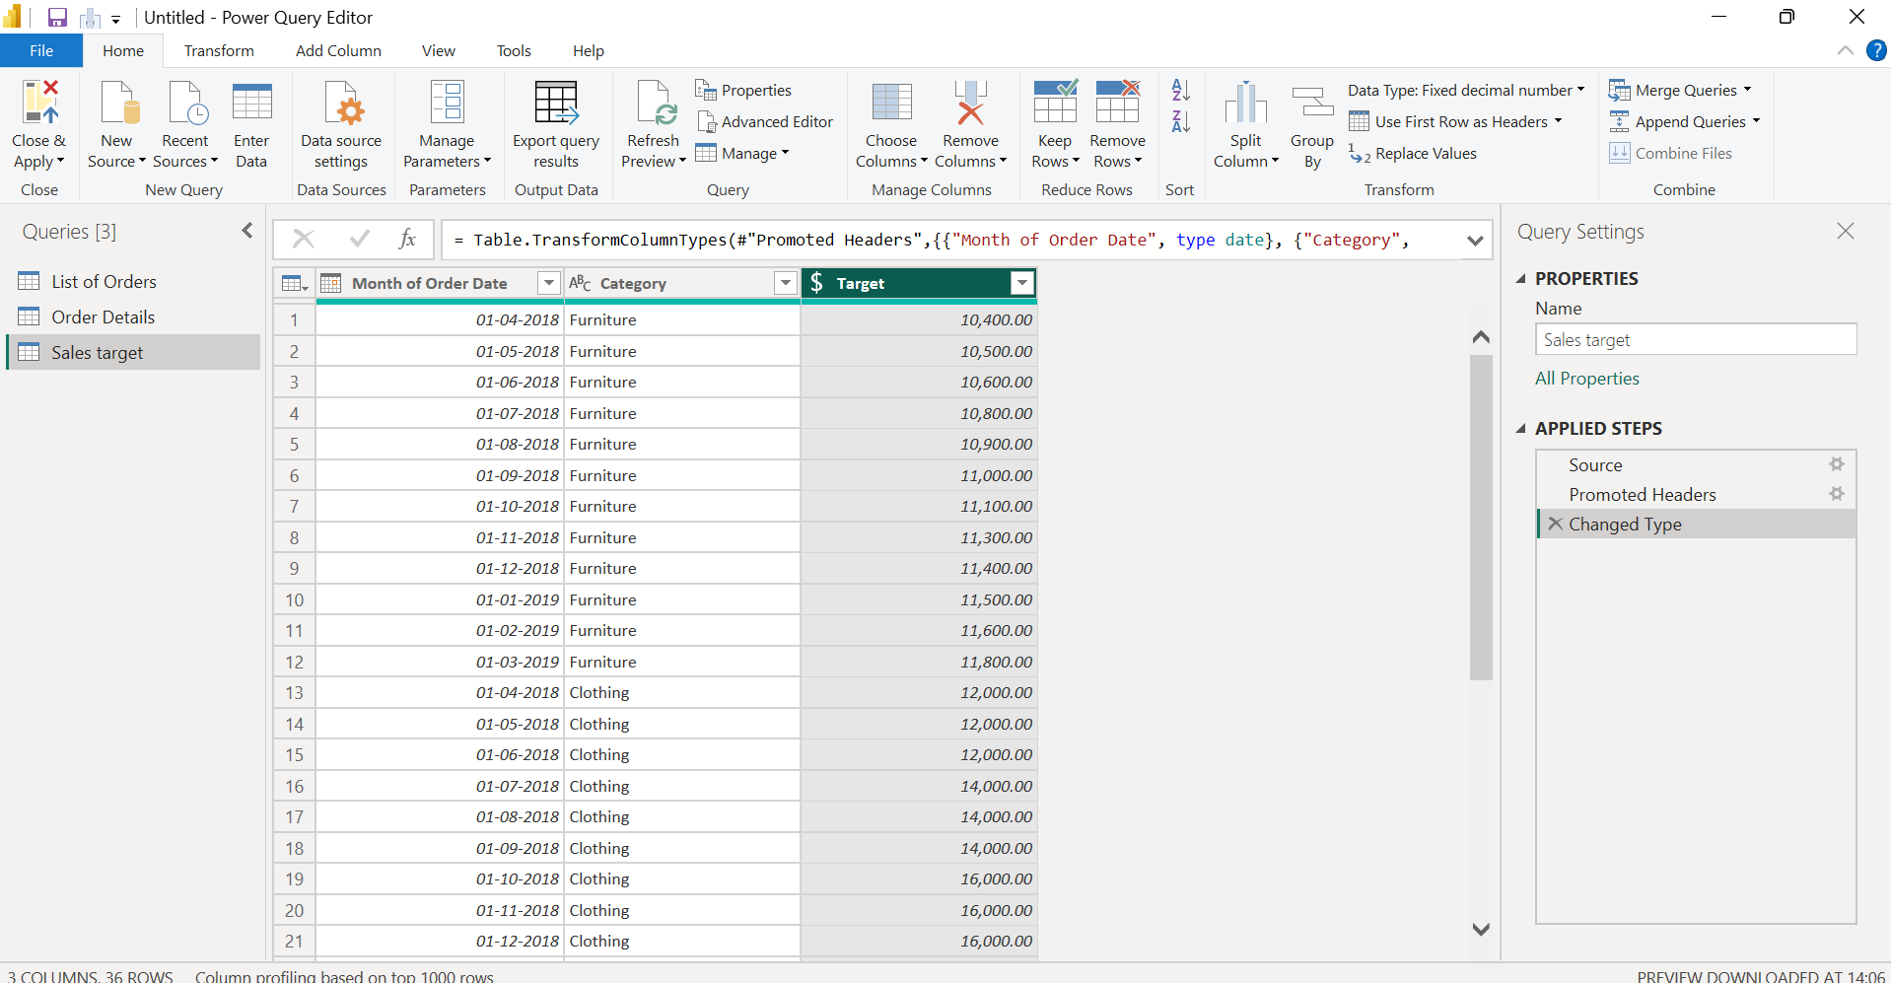
8.Added a new conditional column named "Profit Status" based on the values in the "Profit" column. Change the type :if the profit is less than 0, the label should be "Loss"; if the profit equals 0, the label should be "Break-Even"; and if the profit is greater than 0, the label should be "Profit".
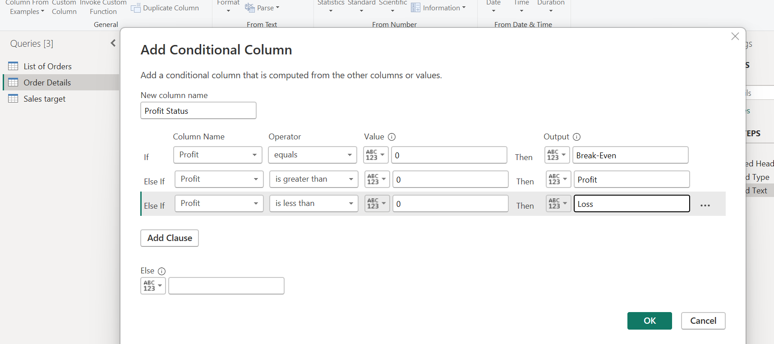
After that a new column was created.
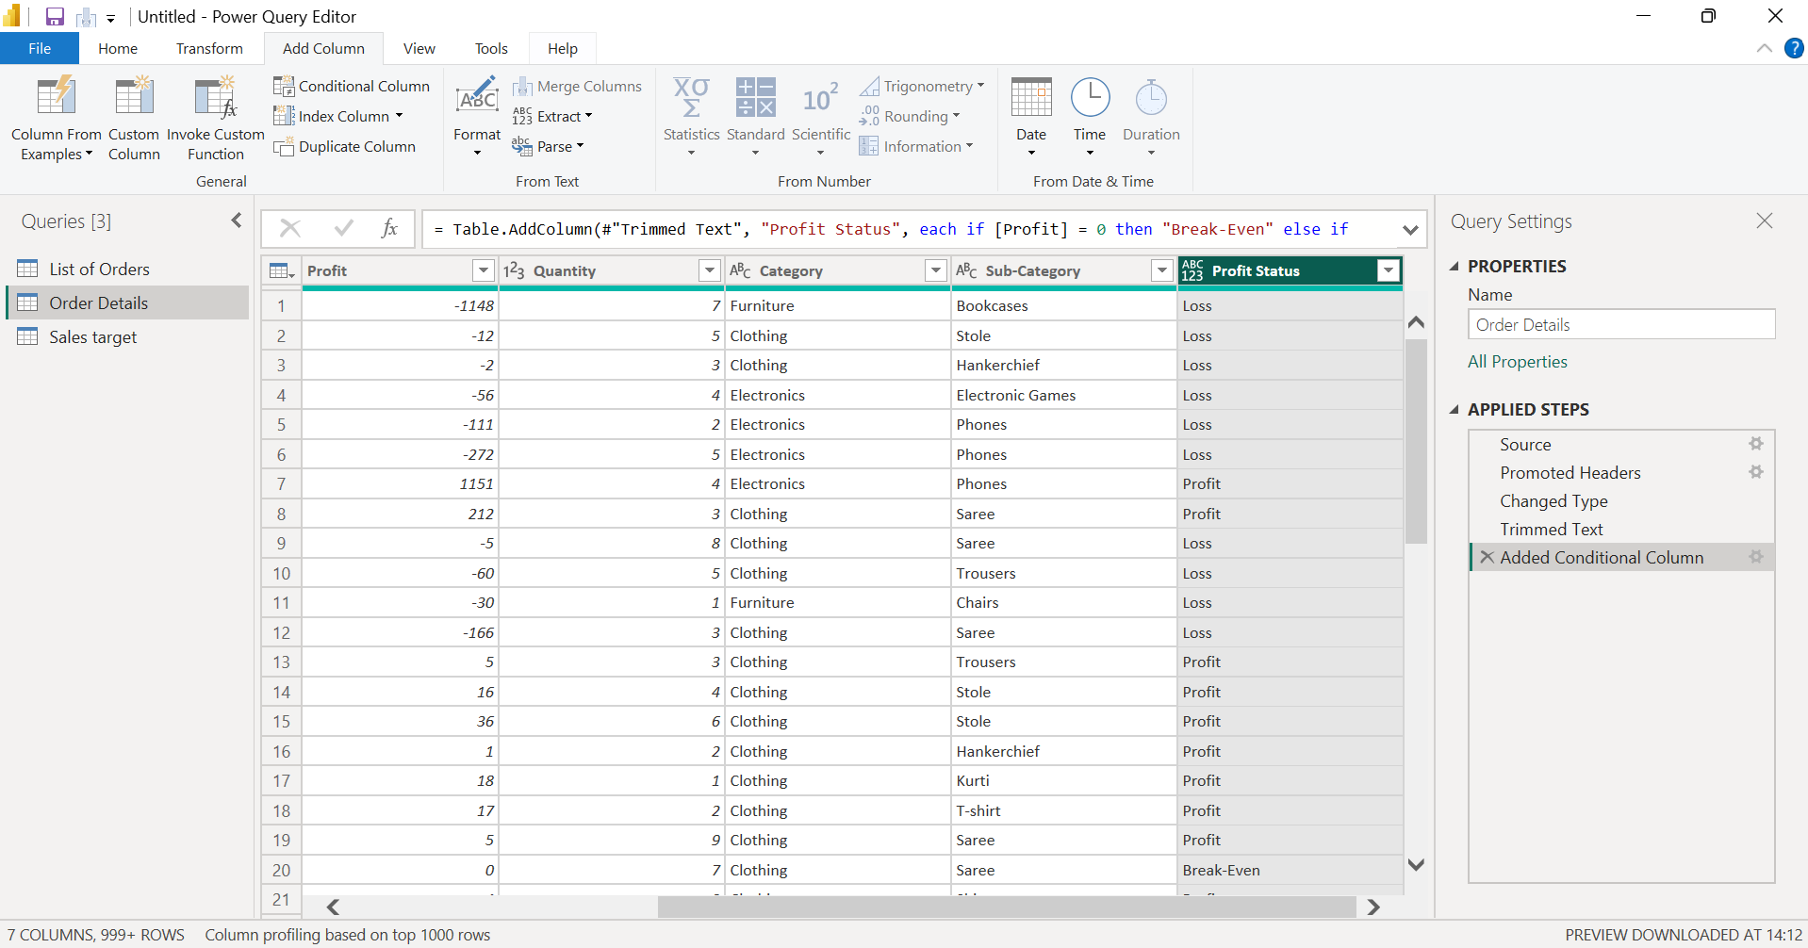9.Created a new custom column named "Profit Margin" as the percentage of "Profit"
divided by "Amount".
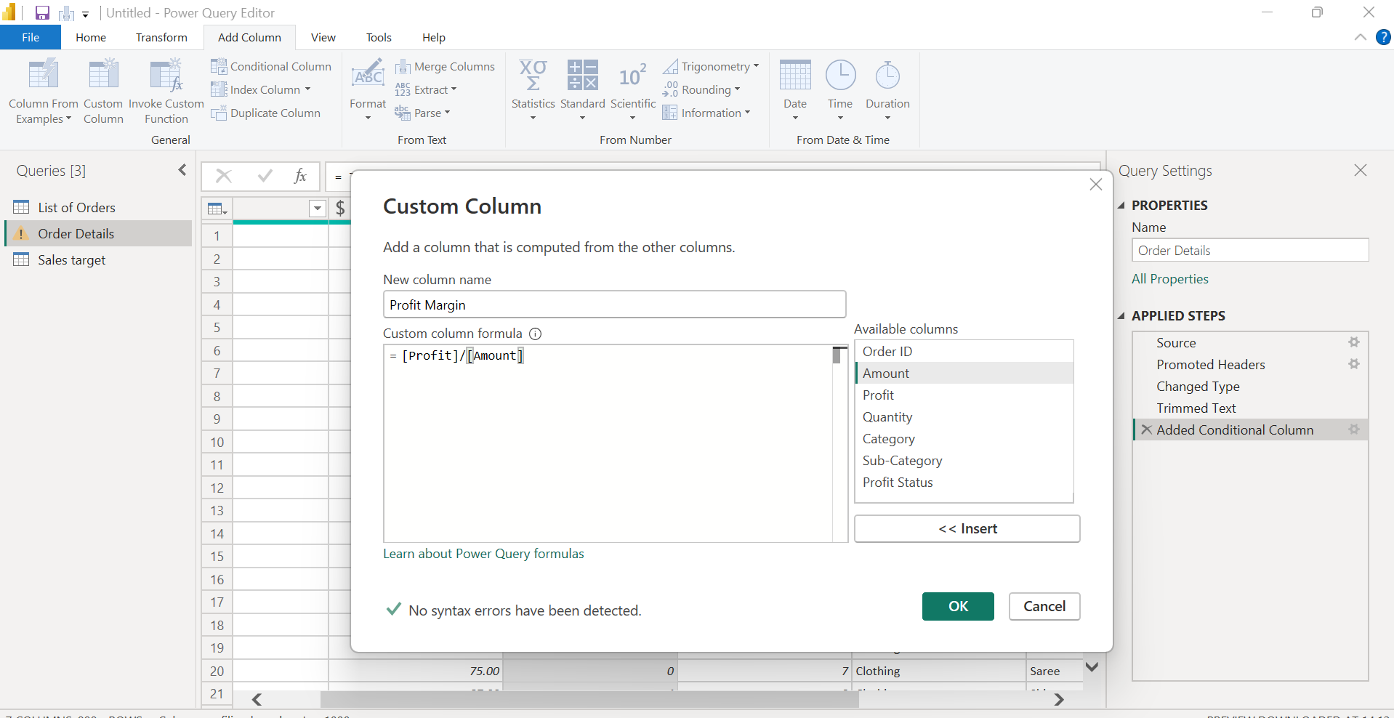
10.After that changed the percentage 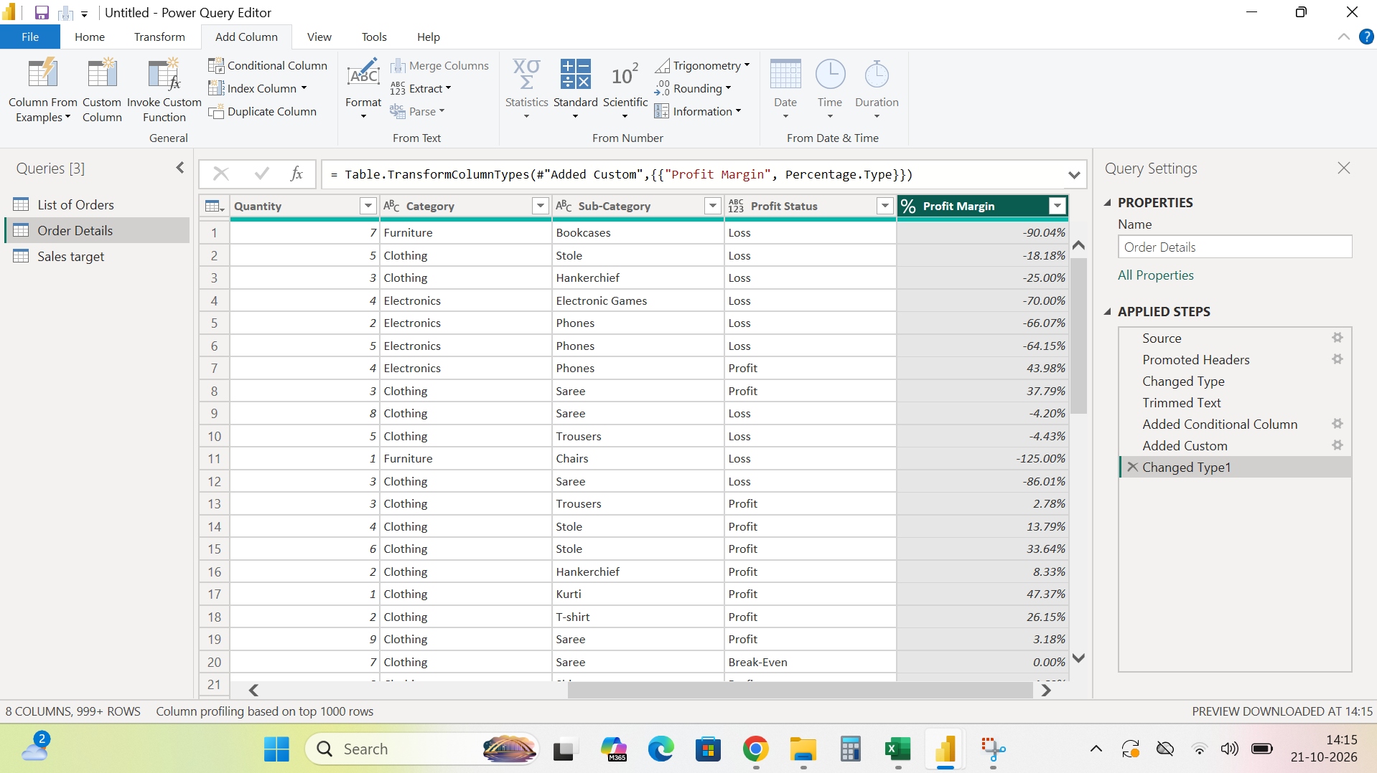
Merging Data :

11.Merged the "List of Orders" and "Order Details" tables into a new single table named
"Orders Data" based on the "Order ID" relationship.
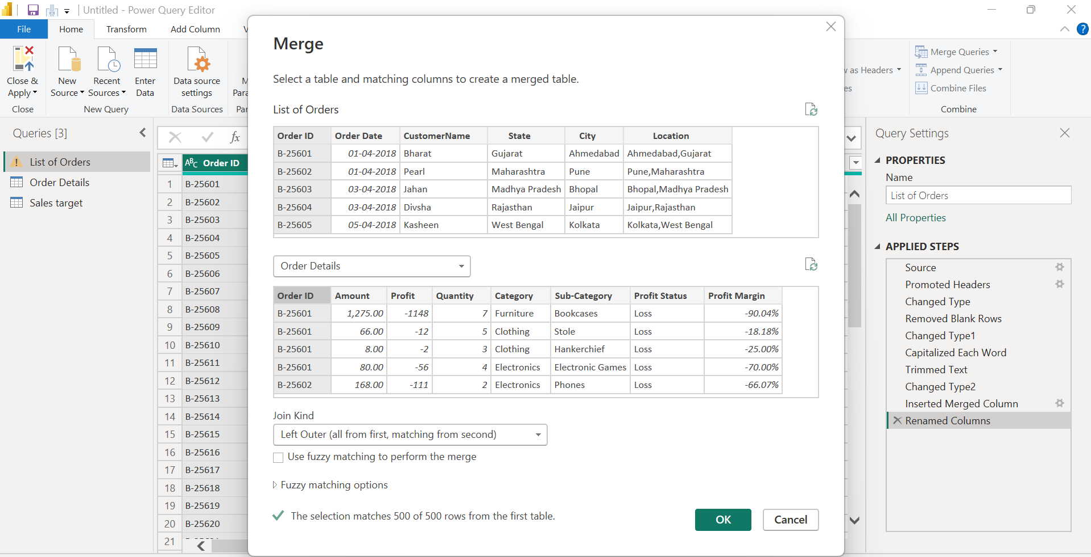
Handling Missing Data & Duplicate Data:
12. No null values
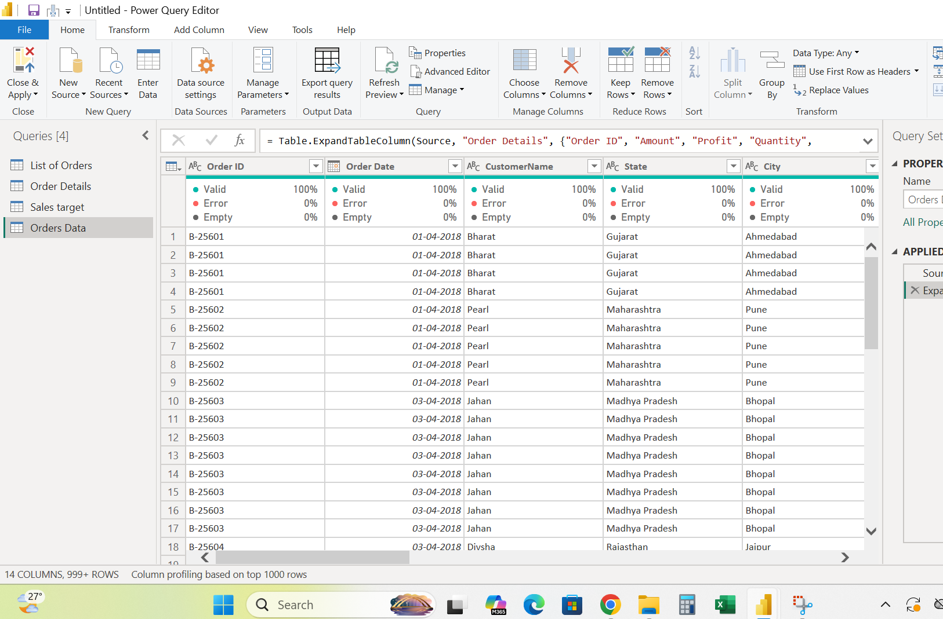
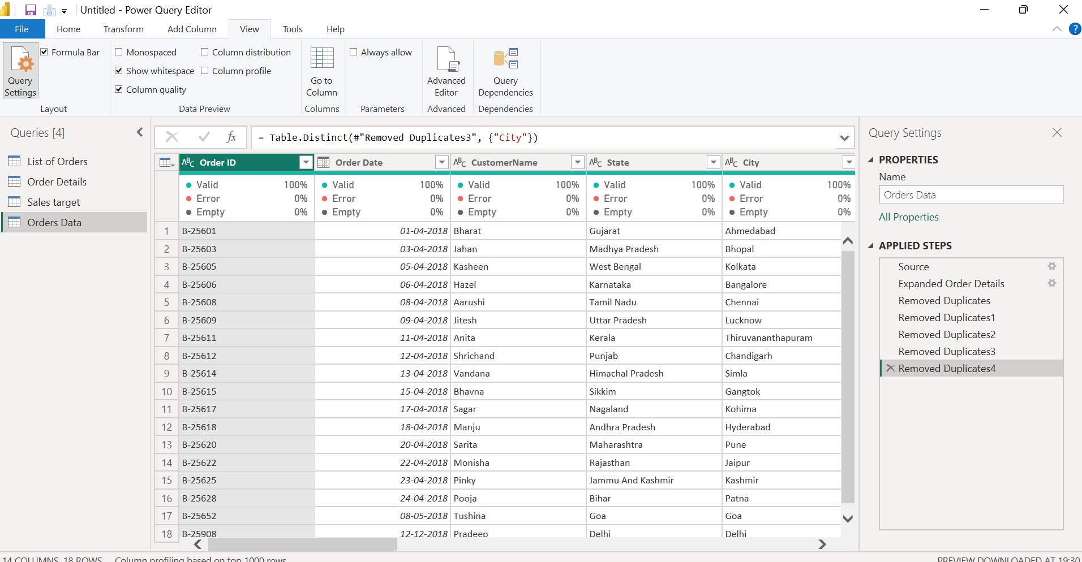
No duplicates Data found

Sorting and Filtering Data:

Sort the orders by Order Date in descending order
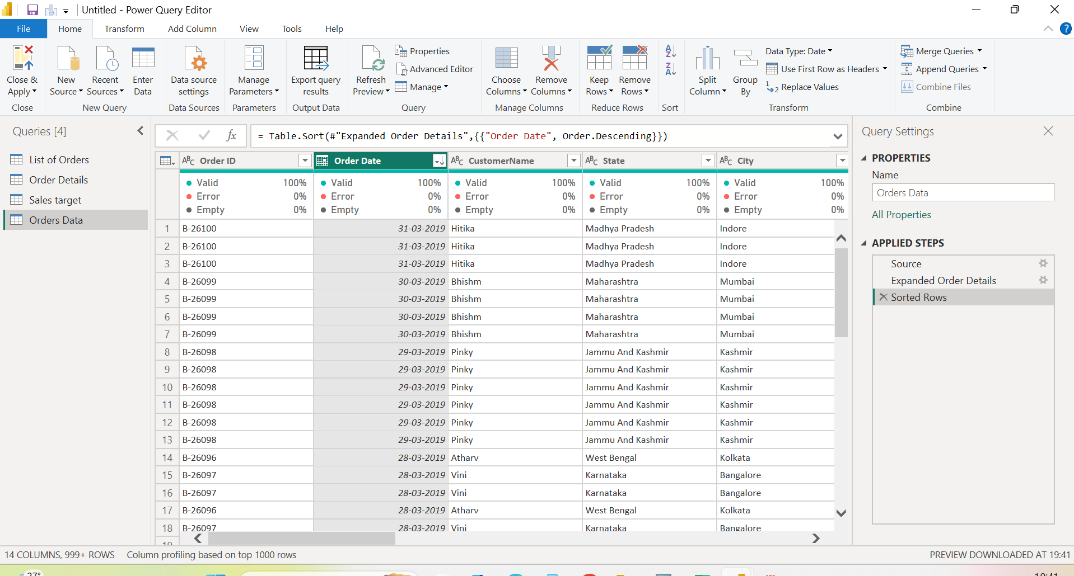
13.Filter the orders to focus only on a specific state Tamil Nadu for
regional analysis.
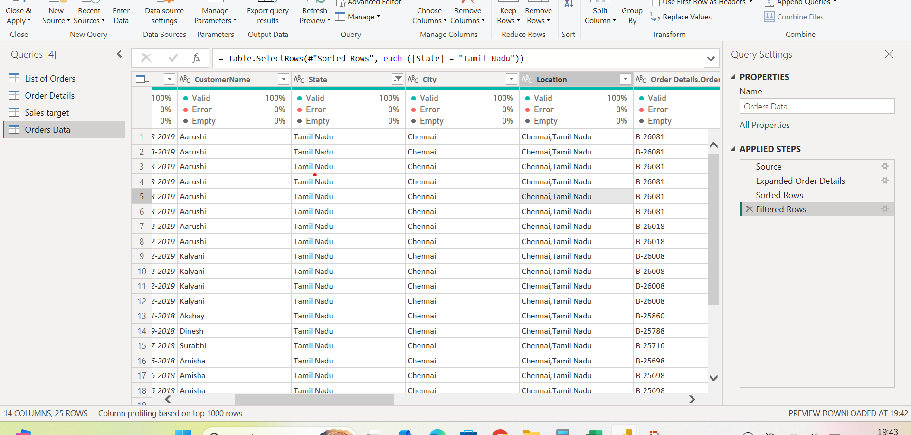
Grouping and Aggregating Data:

14.Duplicate the “Order Details” table and calculated the count of each Order ID,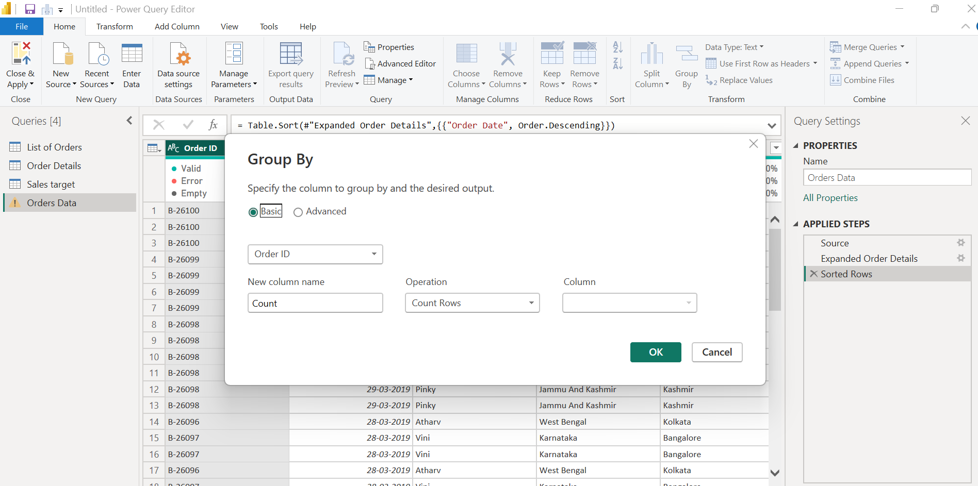
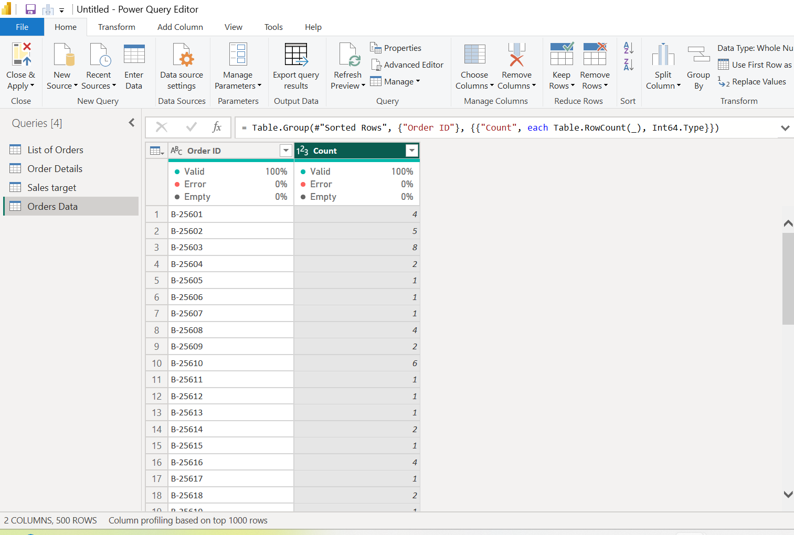
15. total amount by Sub-Category.
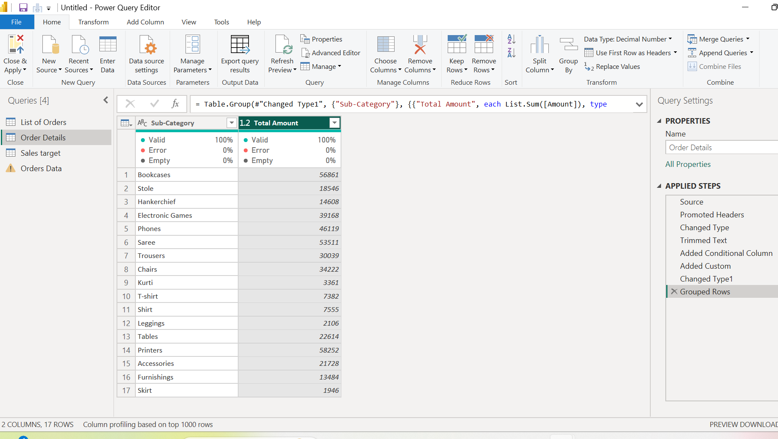
16.average profit by Category

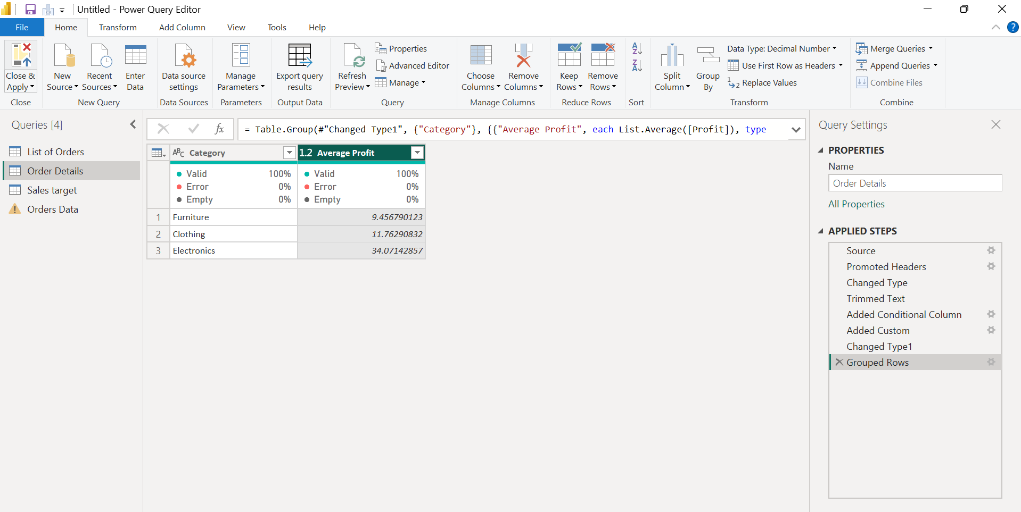
15.Duplicate the “Sales Target” table and aggregate the total target amount by Month of
Order Date.

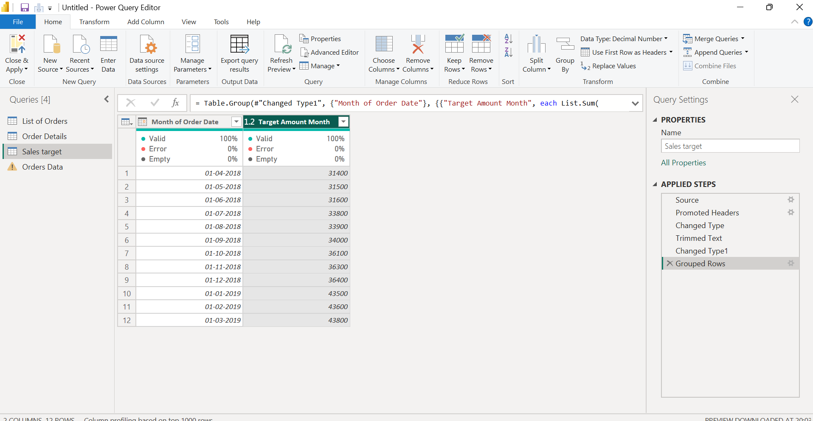
Data Modeling:
Establish a relationship between the “List of Orders” and “Order Details” tables using
the ‘Order ID’ column.
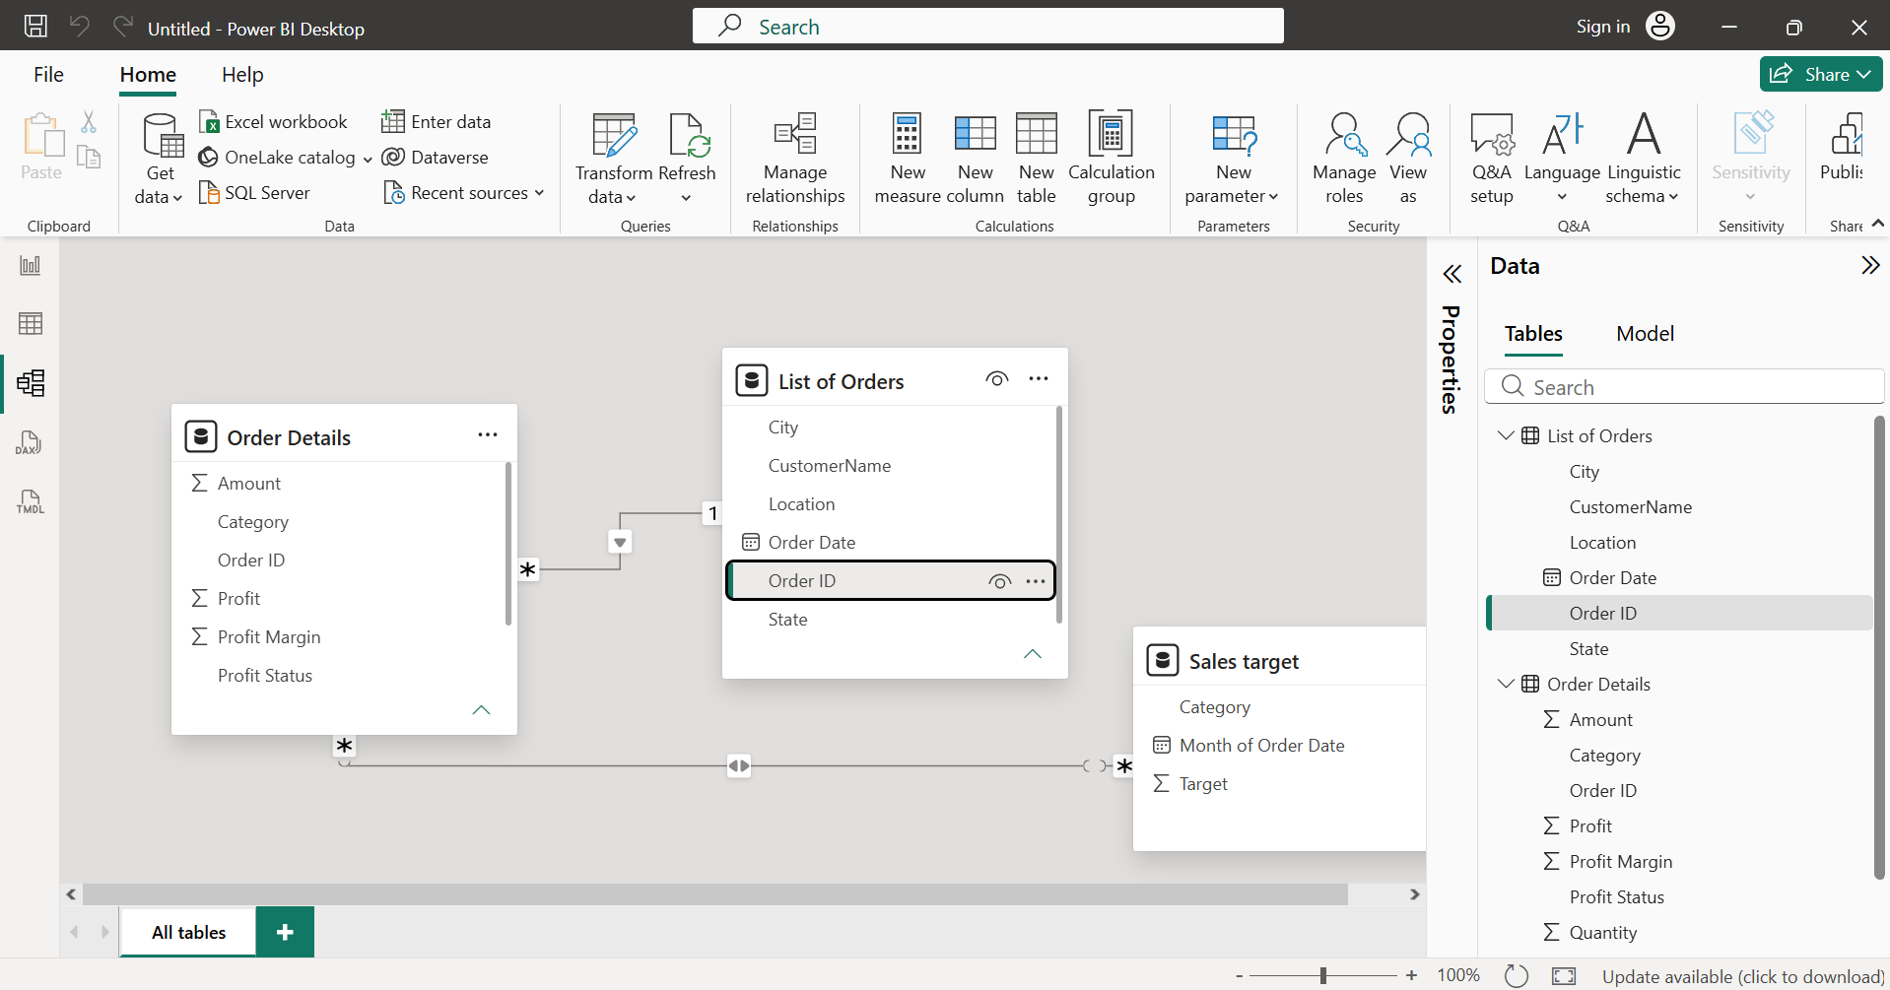
Build a relationship between the “Order Details” and “Sales Target” tables based on
the ‘Category’ column. Click "Manage relationships" and ensure this relationship is
active.